Practical No. 10

Aim: Create a simple PL/SQL program which includes declaration section executable section and exception –Handling section (Ex. Student marks can be selected from the table and printed for those who secured first class and an exception can be raised if no records were found) ii. Insert data into student table and use COMMIT, ROLLBACK and SAVEPOINT in PL/SQL block.

Theory:
PL/SQL(Procedural Language/Structured Query Language) is a programming language that extends SQL and provides procedural capabilities. It is used for developing stored procedures, functions, triggers, and other database objects.

Queries:
1) Write a PL/SQL block to swap two numbers.
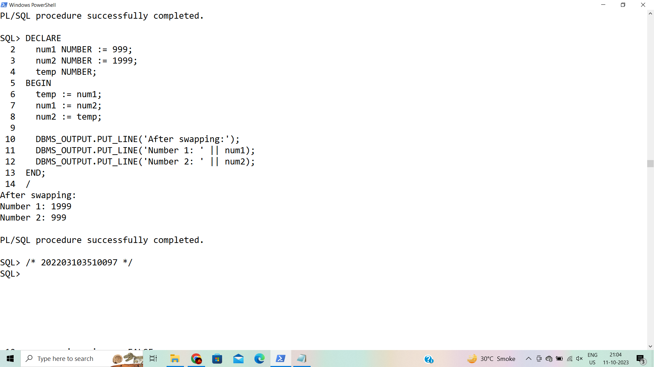

2) Write a PL/SQL block to take personal details (Enrolment Number, Name, Phone Number and Qualification) from user and display it.
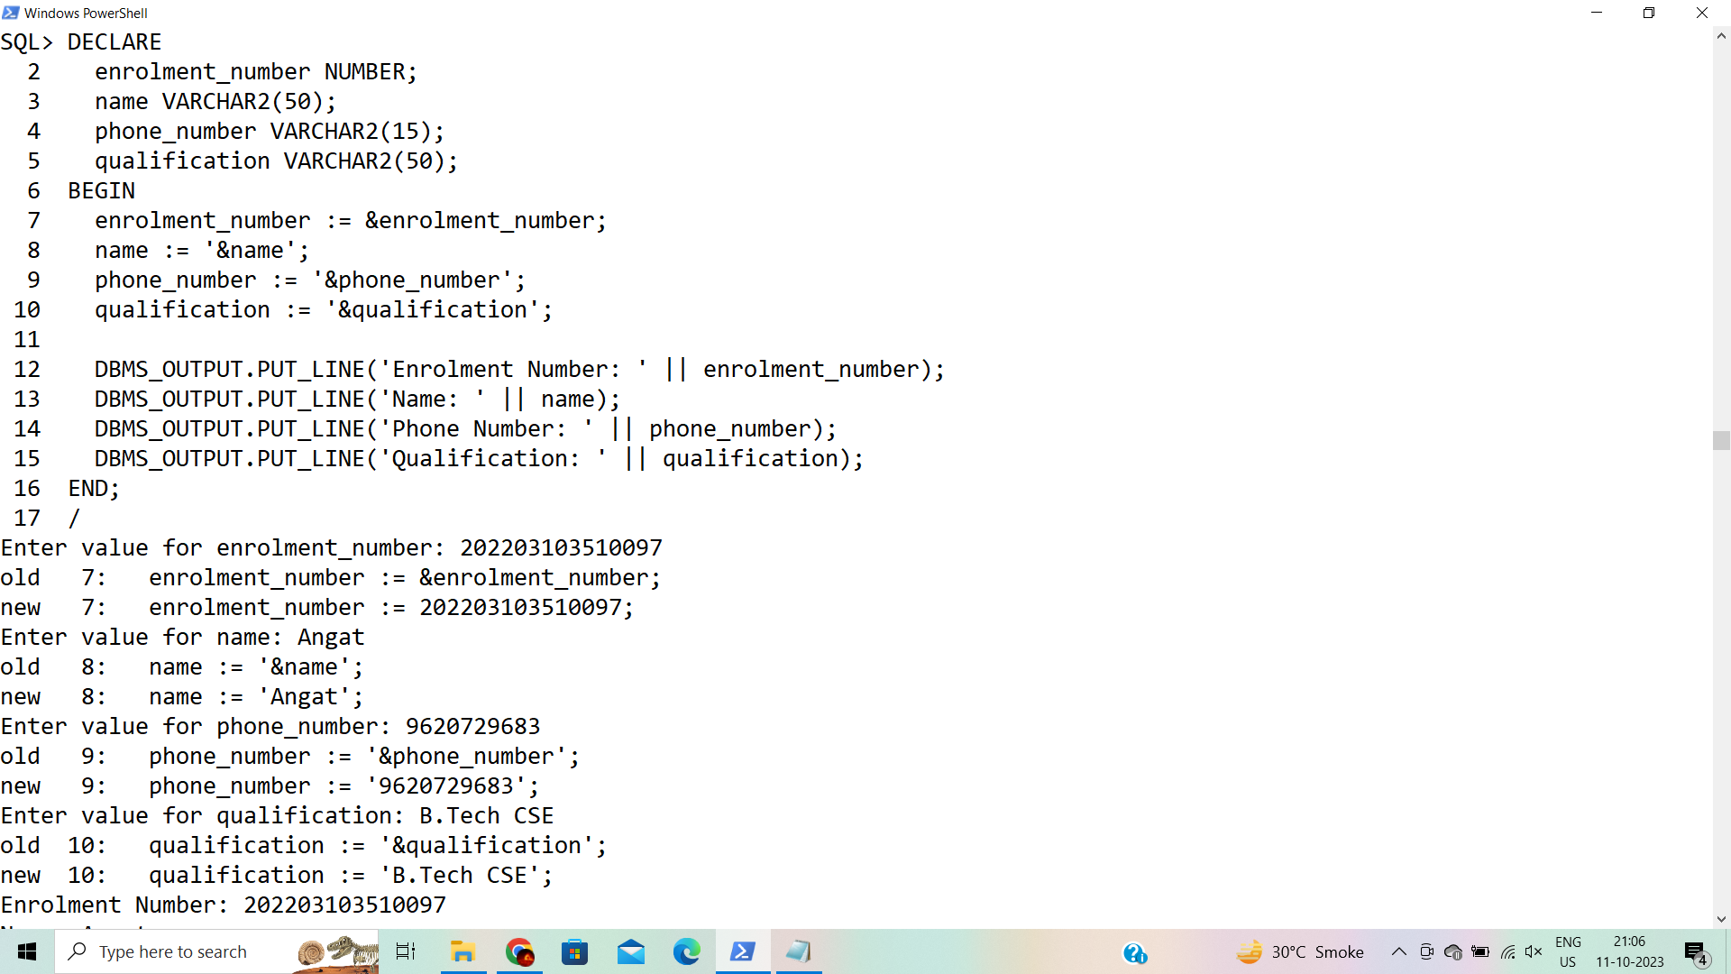
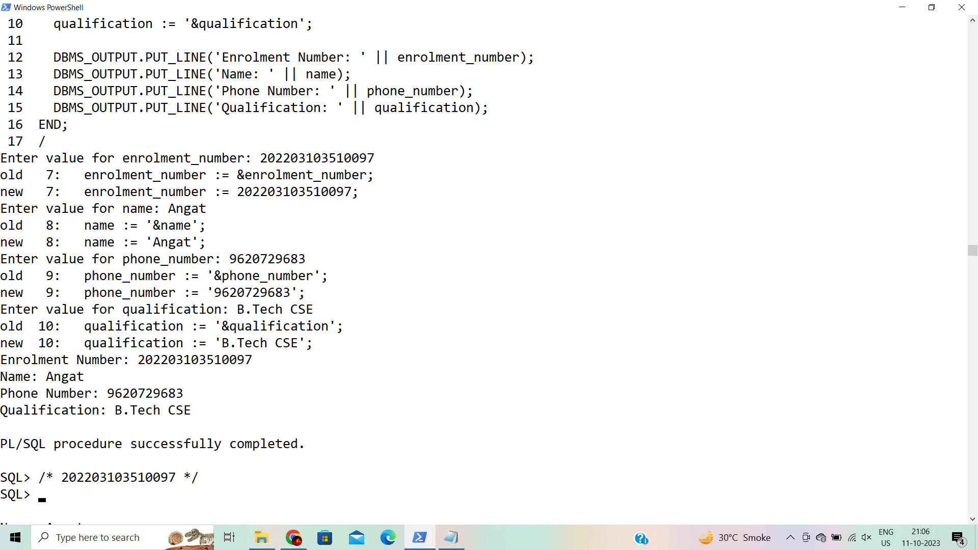

3) Write a PL/SQL block to find given year is leap year or not.
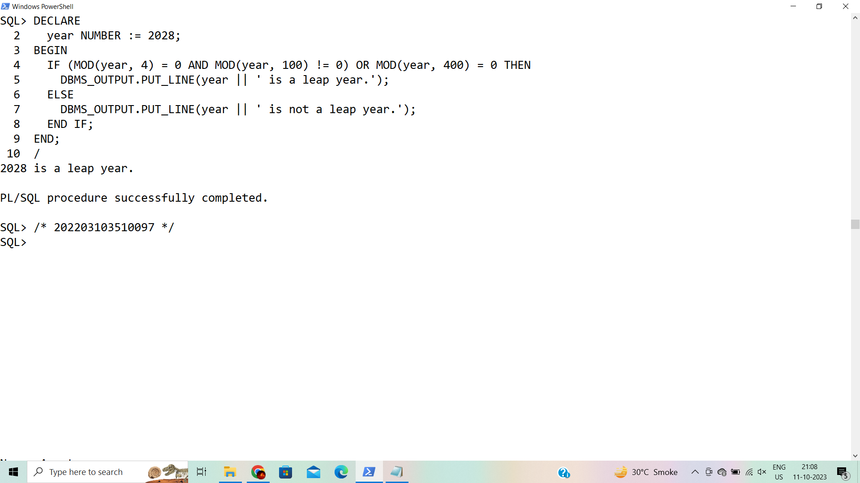

4) Write a PL/SQL block to find factorial of a given number using for loop.
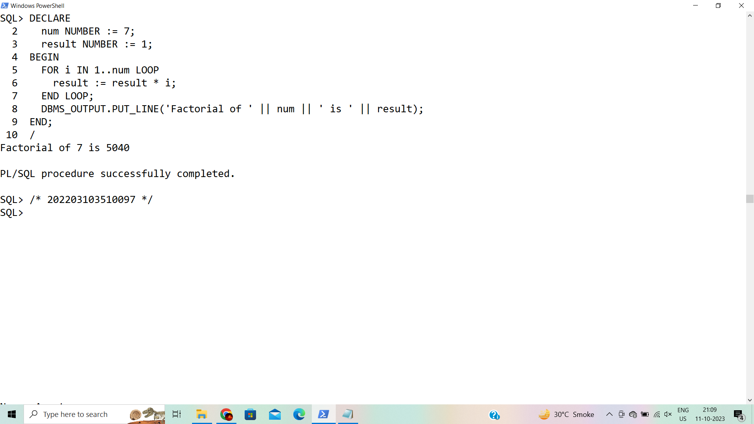

5) Write a PL/SQL block to reverse a given number using while loop.
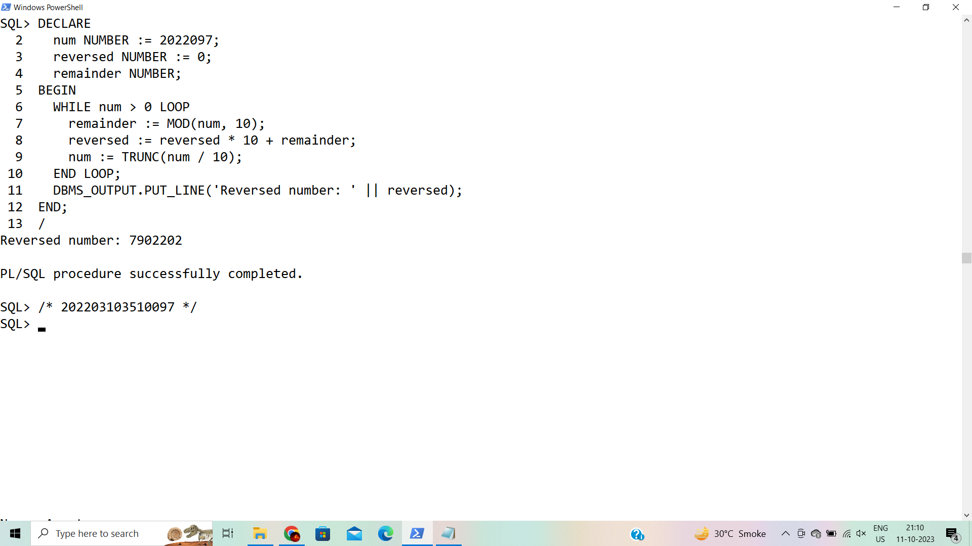

6) Write a PL/SQL block to check whether given number is prime or not.
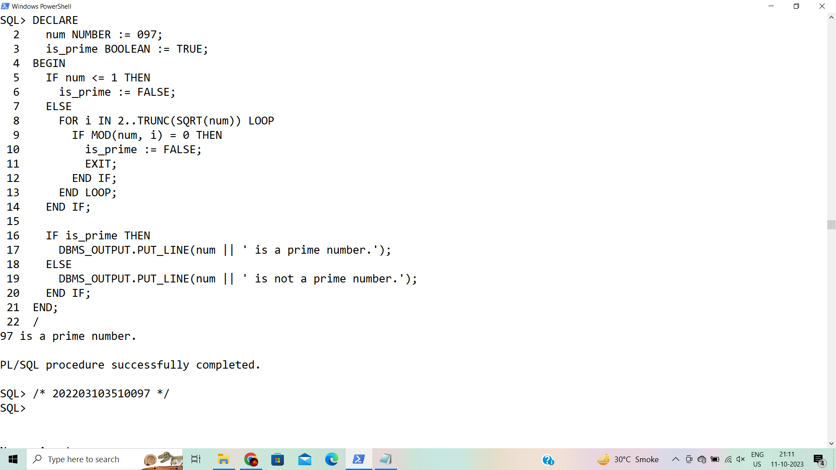

Conclusion: PL/SQL program demonstrates how to declare variables, retrieve and process data from a database table, and handle exceptions. It can be expanded upon to include more complex business logic and transaction management as needed for specific database operations.

